Introduction to CI

Will you be pleased to discover an error, a show stopper, at a crucial stage in your software?

Obviously, the answer is ***No***!

What steps can be taken to detect and fix coding issues at an early stage of the development cycle?

**Continous Integration** (CI) can help in providing a solution.

What is CI?

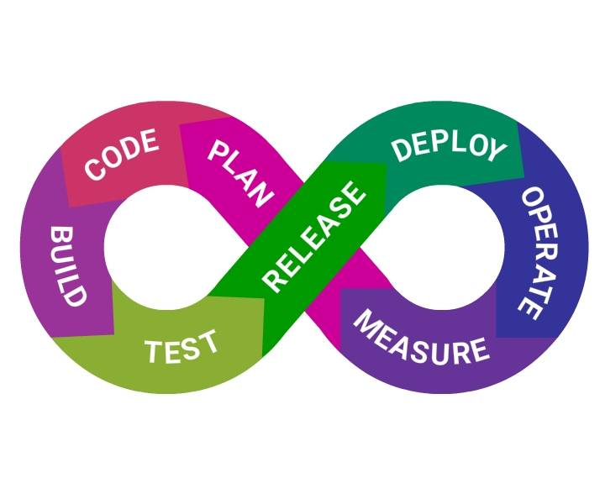

According to Martin Fowler,

**Continuous Integration** is a software development practice where members of a team integrate their work frequently, usually each person integrates at least daily - leading to multiple integrations per day. Each integration is verified by an automated build (including test) to detect integration errors as quickly as possible.

##### Quick Fact

The term **Continuous Integration** was first coined by Grady Booch.

How to Enable CI?

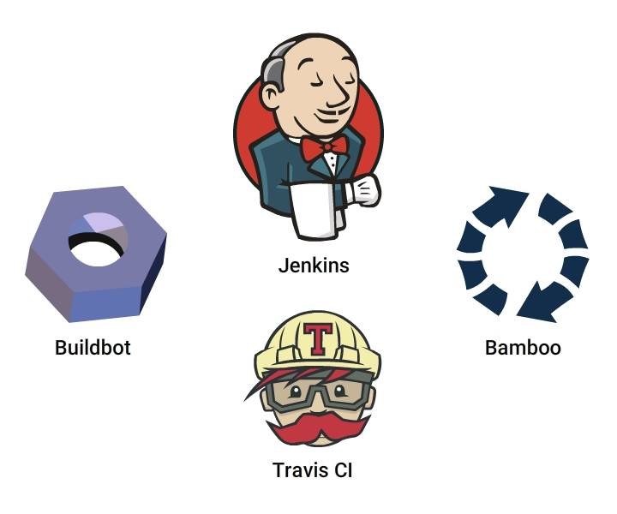

You need a tool to create a CI enabled environment. Jenkins, Travis CI, Bamboo,Buildbot are different tools available to enable CI.

In this course, you will be learning about **Jenkins**, a widely used open source CI tool, written in Java.

##### Quick Fact

Jenkins was earlier referred to as **Hudson**

##### What does Jenkins do?

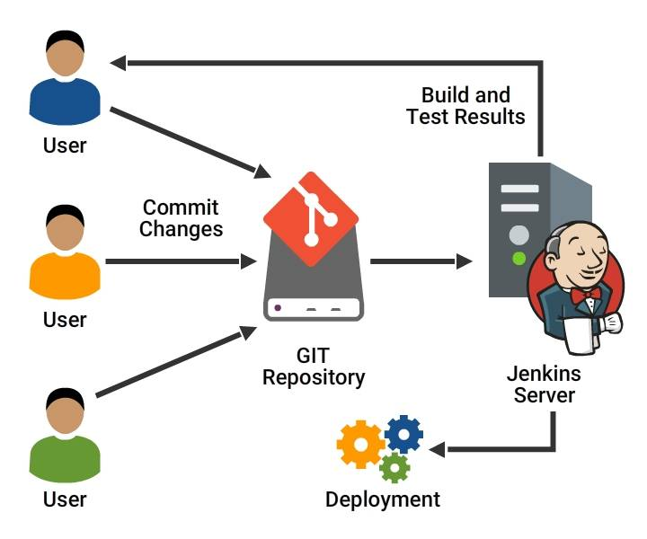

* **Compiles** and **builds** the code
* **Runs** an internal shell or command line script
* **Starts execution** of the integration tests
* **Monitor** execution of tasks
* **Stops build** in case of failure
* **Notify user** on the build status
* **Deploy** in test or production environments

##### Features of Jenkins

* **Easy to install**
* **Easy to configure** various tasks
* **Rich plugin ecosystem** - Integrates with a variety of build, test,deploy,reportingtools
* **Permanent links** - Jenkins provides direct links to the latest or failed build, which can be used for easy communication

##### Features of Jenkins Contd.

* **Extensibility** - Customize Jenkins to suit your needs
* **Distributed builds** - Jenkins can distribute build, test jobs to multiple computers with different operating systems
* **File fingerprinting** - Manages dependencies
* **Email integration**- Emails the build status

##### Difference made by Jenkins

***Pre Jenkins:***

* Source code was completely built and then tested
* Bugs identified during testing in the source code, should be fixed and then re-tested
* Slows the software delivery, as the entire process is manual

***Post Jenkins :***

* Once code change is committed,Jenkins automatically takes care of the build , test and reporting of results.

##### Quick Fact

Jenkins was primarily developed by Kuhsoke Kawaguchi.

##### Pre-Requisites to Install Jenkins

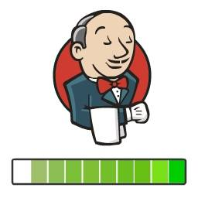

Recommended minimum configuration for installing Jenkins:

* **locally** - Java 8, 256MB RAM and > 1 GB free disk space
* **small team** - Java 8, >1 GB RAM and > 50 GB free disk space

Since all the builds take place on the Jenkins machine , system should have enough disk space for build storage. Jenkins can be installed on **Windows**, **Ubuntu/Debian**, **Red Hat**, **Fedora/CentOS**, **Mac OS**, **X openSUSE**

##### Installing Jenkins

Jenkins can be started from command line or can run on a web application server.

* Download the jenkins.war file from [Jenkins](https://jenkins.io/)
* Start Jenkins directly from Command line with java-jar jenkins.war
* On Successful completion ,Jenkins can be accessed locally from http://localhost:8080/

**To run it from *Tomcat server***

* **Put** the .war file into the webapps directory
* **Start** Tomcat, Jenkins installation will be available on (<http://localhost:8080/jenkins>)

##### Configuring Jenkins

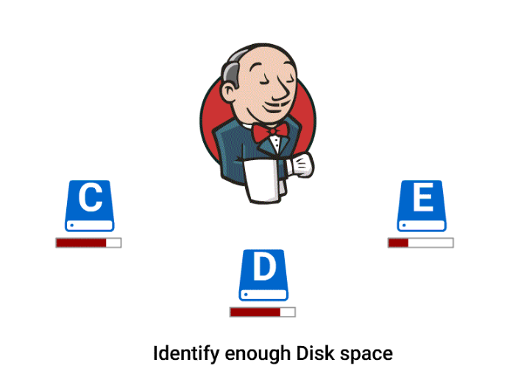

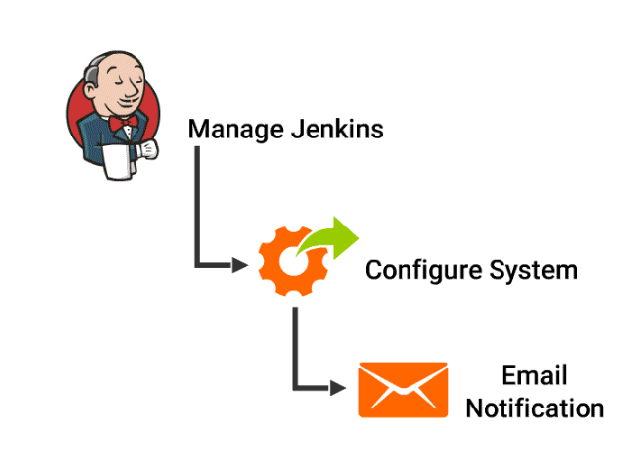

Jenkins installation is now complete. What are the next steps?

* Select the Jenkins home directory (prefer location with enough free space)
* Decide number of concurrent job executions to be allowed on ***Jenkins*** machine

Configuring Jenkins Contd.

* Add custom environment variables
* Mention SMTP server,user email suffix in the email notification section
* Configure the location of JDK installation
* To build Maven applications configure the location of Maven Home

You can perform these tasks by selecting ***Configure System*** under ***Manage Jenkins***.

Extending Jenkins Functionality

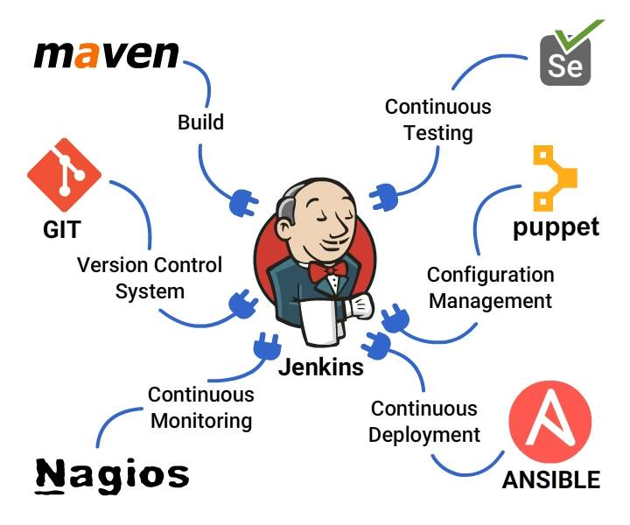

* Once Jenkins is installed, it is time to configure it, to fit your needs
* Jenkins has relatively few abilities, but it aids the s/w developers by providing a variety of plugins
* Plugins are add-ons that allow Jenkins to interact with many other softwares
* The exact plugins you install depends on the nature of your project

##### Plugins in Jenkins

[Jenkins Plugins Index](https://plugins.jenkins.io/) provides you the various plugin options such as

* **Source Control**: Git, SVN, Mercurial
* **Testing** : Selenium, Windmill
* **Triggers**: Jabber, Directory watchers
* **Artifact**: To copy components between projects like Amazon S3, SCP